Configuration Guide

Project PJT03023: Power Factor Billing – December 2014 Release 4A

Document Information 3
Revision History 3
1 Business Scenarios 4
1.1 Table - Register Group Configuration 4
1.1.1 Organizational Units 4
1.2 Table - Bill Install Configuration 5
1.2.1 Organizational Units 5
1.4 Billing – Rate Configuration 6
1.4.1 Organizational Units 6
2. Sign-off 9
REVIEWER(S) 9
APPROVER(S) 9
3. Contributors 10

Document Information
Document Purpose | Power Factor Meter Reading and Billing Configuration
Document Owner | Mary Jane Afable
Business Owner | Zach Pakkala
File Name(s) | PJT03023.SAP.CD.Billing.PF.Rates.Configuration.docx
Stored at | SharePoint  Smart Grid Enablement ➔ SGE Documents ➔ Release 4 Complex Billing ➔ Release R4a ➔ 08 Work In Progress ➔ Execute ➔ Configuration Documents ➔ PreCutover to Interval Billing

Revision History
Version | Date | Author | Comments
0.1 | 12/20/2013 | Pete Hirth | First Draft
0.2 | 1/8/2014 | Pete Hirth | - 1.2.1 Organizational Units:  Updated the ZTCC_BILINS_ELEC configuration information and attached document.  - 1.4.1 Organizational Units:  Updated the Billing Master Data and attached document.  - Added new billing operands.  - Added new billing rates.  - Added new register rate type.  - Added a list of rates to the ‘Rate Determination SAP Path’ table.
1.0 | 9/24/2014 | Mary Jane Afable | - Updated Billing Master Data and sttached configuration to include read-only PF scenario  - Adjusted registed group to use ESM_C for single phase registers, including EZWG and ZTCC_BILINS_ELEC attachments.
1.1 | 04/10/2014 | Rajesh Pandey | Modification in rate : ES_POWERFR to supress display of read only max demand on customer bill

Power Factor

1 Business Scenarios

1.1 Table - Register Group Configuration

1.1.1 Organizational Units

Type: Table Configuration

Logical Component: Register Group

Object: EZWG

Name: Register Group

Register Group Table Updates (See attached document below for more detail)

.
- ESM_C – Transport register group ESM_C entries from E2Q-100 to ECP.

(ESM_C entries already exist in the E2Q-100 table)

- ESM_D – Transport register group ESM_D entries from E2Q-100 to ECP.

(ESM_D entries already exist in the E2Q-100 table)

Reference Document

Please reference the attached document which will list the table rows and field values that need to be transport from E2Q-100 to ECP production.
- Table rows (11) for register group ESM_C.
- Table rows (12) for register group ESM_D.

1.2 Table - Bill Install Configuration

1.2.1 Organizational Units

Type: Table Configuration

Logical Component: Bill Install

Object: ZTCC_BILINS_ELEC

Name: Billing Installation at the register level: Residential Elec

Bill Install Table Updates (See attached document below for more detail)

.
- GSD_1120 – Add entries in the bill install table for register groups ESM_C and ESM_D.

- GSD_1130 – Add entries in the bill install table for register groups ESM_D and ESM_D.

- GSD_1140 – Add entries in the bill install table for register groups ESM_D and ESM_D.

- GSD_1150 – Add entries in the bill install table for register groups ESM_D and ESM_D.

Note: Only GSD_1120 and GSD_1130 will be used for Pre-Cutover to Interval Billing.

Reference Document

Please reference the attached document which will detail the following file configuration items:
- New entries for rate categories GSD_1120, GSD_1130, GSD_1140 and GSD_1150.
- Major table column keys.
- Billing rate types and other billing related information.
- Register related information.
- Consumption related information used in SAP estimation.

1.4 Billing – Rate Configuration

1.4.1 Organizational Units

Type: Rate Configuration

Logical Component: Billing Master Data

Object: Billing Master Data

Name: Billing Master Data

Power Factor Billing Process (See attached document below for more detail)

.
- Rate Type – New register rate types for AMI meter’s kwh and kvarh index registers.

- Billing Rate – New billing rates to transfer the kwh and kvarh index register readings for AMI meters to SAP billing and to calculate the power factor for AMI meters.

- Schemas – Add the new billing rates to the SEC_ELEC billing schema.

- Rate Determination – Add the new rate types and the new billing rates to rate determination for rate categories GSD_1120 and GSD_1130.

Reference Document

Please reference the attached document which will detail the following billing related configuration items:
- Operands
- Rates
- Schemas
- Rate Categories
- Rate Types
- Rate Determination

Configuration

Operand SAP Path
Utilities Industry -> Billing -> Master Data -> Define Operands

New Operands | Comments
QNT1CKWHRA | This is register operand with a weighting key of '01' (run time).
QNT1CKWHBA | This is normal usage operand with a weighting key of '01' (run time).
QNT1CKVHRA | This is register operand with a weighting key of '01' (run time).
QNT1CKVHBA | This is normal usage operand with a weighting key of '01' (run time).
FCT1C_PFA | This is normal usage factor operand without a weighting key (run time).
PWERFTCALC | This is normal usage factor operandwithout a weighting key (run time).
DEM1C_PFRO | This is normal usage demand operand without a weighting key (run time).
DEM1C_PFRU | This is normal usage demand operand without a weighting key (run time).
FCT1C_PFR | This is normal usage factor operand without a weighting key (run time).
FCT1C_PF_R | This is normal usage factor operand without a weighting key (run time).
FCT1C_PFRO | This is normal usage factor operand without a weighting key (run time).

Rate SAP Path
Utilities Industry -> Billing -> Master Data -> Define Rates

New
Rates
ES_KWHREGA | Elec Sec - KWH Register from AMI meter
ES_KVHREGA | Elec Sec - KVARH Register on AMI meter
ES_POWERFA | Elec Sec - Power Factor
ES_POWERFR | Elec Sec - Power Factor (Read-Only)

Schema SAP Path
Utilities Industry -> Billing -> Master Data -> Define Schemas

Existing Schema
SEC_ELEC

Rate Category SAP Path
Utilities Industry -> Billing -> Master Data -> Define Rate Categories

Existing Rate Categories | Billing Class
GSD_1120 | C&I
GSD_1130 | C&I

Rate Type SAP Path
Utilities Industry -> Billing -> Master Data -> Define Rate Types

New Register Rate Types | Set on AMI Meter Register
KWH_R | KWH - Index
KVARH_RB | KVARH – Index (Billed PF)
KVARH_RR | KVARH – Index (Read-Only PF)

Rate Determination SAP Path
Utilities Industry -> Billing -> Master Data -> Define Rate Determination

Existing Rate Categories | New Rate Types | New Rates
GSD_1120 | KWH_R | ES_KWHREGA
GSD_1120 | KVARH_RB | ES_KVHREGA  ES_POWERFA
GSD_1120 | KVARH_RR | ES_KVHREGA  ES_POWERFR
GSD_1130 | KWH_R | ES_KWHREGA
GSD_1130 | KVARH_RB | ES_KVHREGA  ES_POWERFA
GSD_1130 | KVARH_RR | ES_KVHREGA  ES_POWERFR

Configuration Changes for R4C :

Configuration changes have been done to supress printing of read only max demand on bill print of customer.

Rate : ES_POWERFR

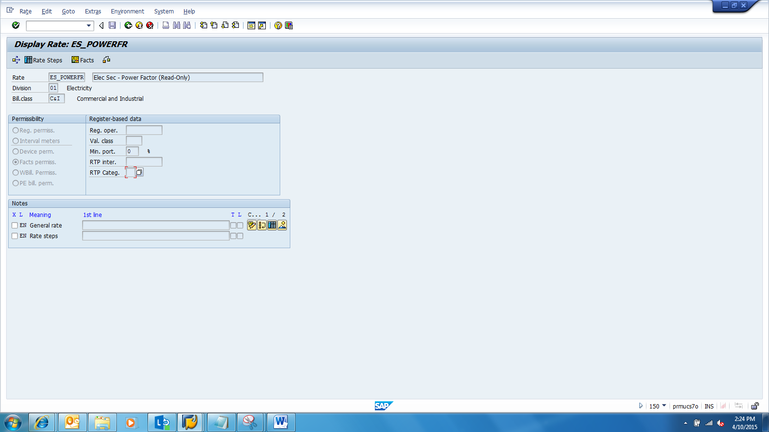

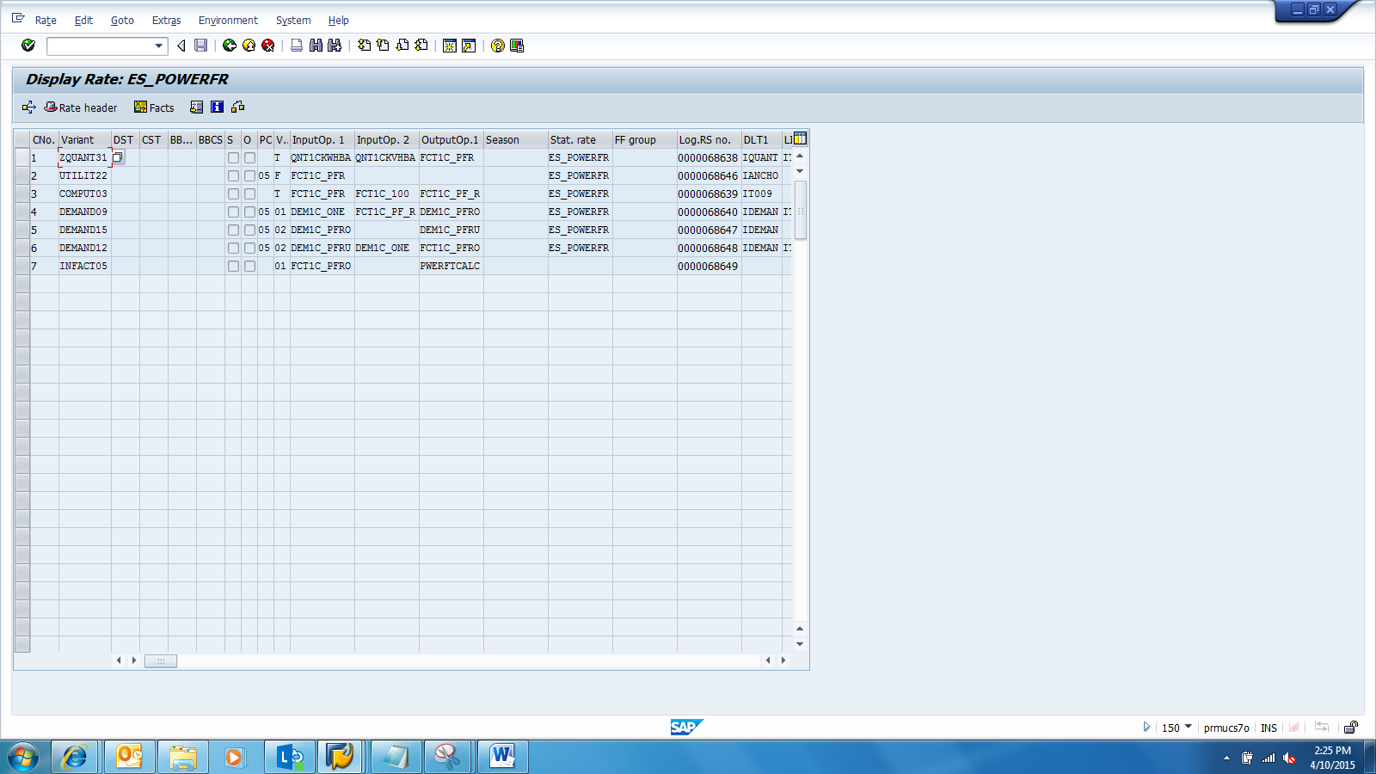

Solution Manager Sub-Process Path: | N/A
Document Name: | PJT03023.Power.Factor.Configuration.Document.Billingv0.2.docx
Created By: | Pete Hirth |  | Date Created: | 12/20/13
Change History:
Support Ticket Number (post go-live) | Transport Number | Changed By: | Description of Change: | Change Date:

- Contributors
Name | Organization | Area of Contribution
Pete Hirth | Consumers Energy | ECC Billing
Mary Jane Afable | SAP | SAP Billing
Manoj Ajgaonkar | SAP | SAP QA Advisor

